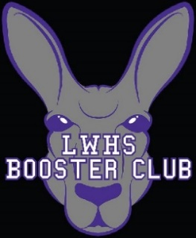

Lake Washington High School Booster Club
6:30-7:30pm, May 10, 2021 —Executive Board Meeting
AGENDA
 | Item | Presenter / Role
1. | Call to Order/Approve April Minutes | Janis/Mary
2. | Treasurer Update: Monthly Reports, Resale Cert | Britt
3 | President Report: Scoreboard, eoy/summer | Janis
4.  5. | Athletic Director Update: sports, scoreboard, COVID  Adjourn | Rick  Janis

